Name : nada ehab Mohamed

Section 8

**Q1: Calculate the time for each process, define the priority?**

Answer :

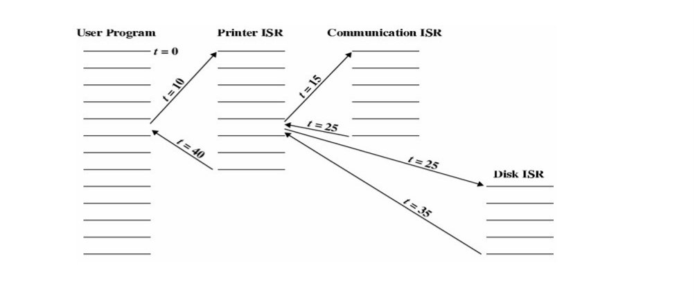

1. Communication ISR ( 10 seconds )
2. Disk ISR ( 10 seconds )
3. Printer ISR (10 seconds )